General Information
Official Hotel and Conference Venue
Westin Virginia Beach Town Center
4535 Commerce St.
Virginia Beach, VA 23462
Phone: 757-557-0550

Time Zone
Virginia Beach observes Eastern Daylight Time
Parking
Complimentary On-Site Parking. The self-parking entrance is located on Market St between Columbus and Commerce St.
What to Pack
Attire is business casual for the conference during the day. We do recommend you dress in layers as temperatures in meeting rooms can vary. Masks are not required; however, you are welcome to wear at your discretion.
Registration
On-site Registration
The registration desk is located in the Foyer on the second floor of the hotel and will be open from 7:00am – 5:00pm most days. See below for exact times.
Security
Limited C or D Distribution sessions require your CAC/PIV card for entering the room. If you do NOT have a CAC/PIV and would like to attend those CUI sessions you will have to submit a visitors request by the deadline. The deadline to submit visit requests via DISS is 25 August 2023. For more information please visit www.itea.org
Badges
If you registered before Friday August 25th your badge will be ready for pick-up on Monday at 3:00pm at the registration desk.

A Look at the Week
Monday, 28 Aug – Registration
- Registration opens from 3:00PM – 5:00PM

Tuesday, 29 Aug – Pre-workshop tutorials (tutorials are a separate fee from workshop)
- Registration opens from 7:00AM – 5:00PM
- Tutorials 8:00AM – 12:00PM and 1:00PM – 5:00PM
- Exhibitor Set-up 8:00AM – 5:00PM
- STEAMhack Chain Reaction Challenge 1:00PM – 4:00PM
- STEAMhack Awards ceremony 5:00PM

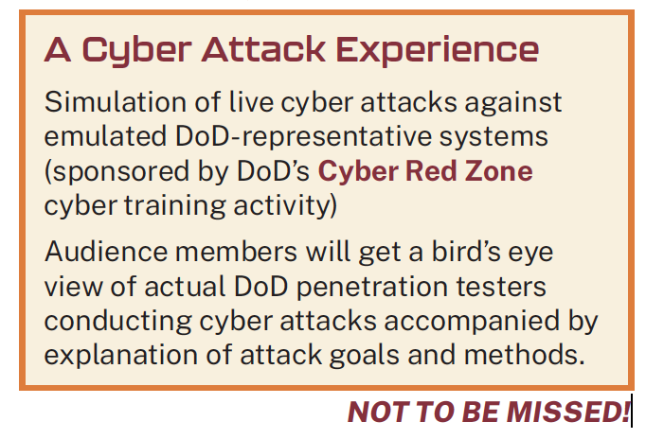
Wednesday, 30 Aug – Full workshop
- Registration opens from 7:00AM – 5:00PM
- Opening Ceremony 8:00AM – 10:00AM
  - Live Cyber Attack Experience!
- Exhibits open 9:00AM – 5:00PM
- Featured Speakers 10:30AM – 2:30PM
- Technical Sessions 3:00PM – 5:00PM
- Cocktails with our Exhibitors 5:00PM – 6:30PM

Thursday, 31 Aug – Full workshop
- Registration opens from 7:00AM – 5:00PM
- Featured Speakers 8:00AM – 10:10AM
- Cyber T&E of Generative AI Systems 10:30AM – 12:00PM
- Exhibit Hall open 9:00AM – 3:30PM
- Technical Sessions 1:00PM – 3:00PM
- Closing Keynote 3:30PM – 5:00PM
- Exhibitor tear down 3:30PM – 7:00PM
- Workshop Concludes 5:00PM

Coffee in the morning and refreshments in the afternoon as well as designated AM & PM breaks in the Exhibit Area will be made available on Wednesday & Thursday. Lunch will also be served both days. Final Agenda

STEAMhack™ Chain Reaction Challenge

The STEAMhack™ Chain Reaction Challenge is a speed-building event where teams of 3–6 high school students receive a kit of materials and about 3 hours to build the most impressive chain reaction-style machine. This year, students will have to “Catch a Meteor” by building machines to launch and catch a meteor, and integrate the reason for catching a meteor into the story described by the team prior to the triggering of the chain reaction. Competition will take place Tuesday, August 29th at 1pm with an Awards ceremony to follow. Come cheer on the high schools participating in this special event!

